Creating the 1094-C

From Personnel > Maintenance > ACA 1094 YTD Data, complete the following and Save.

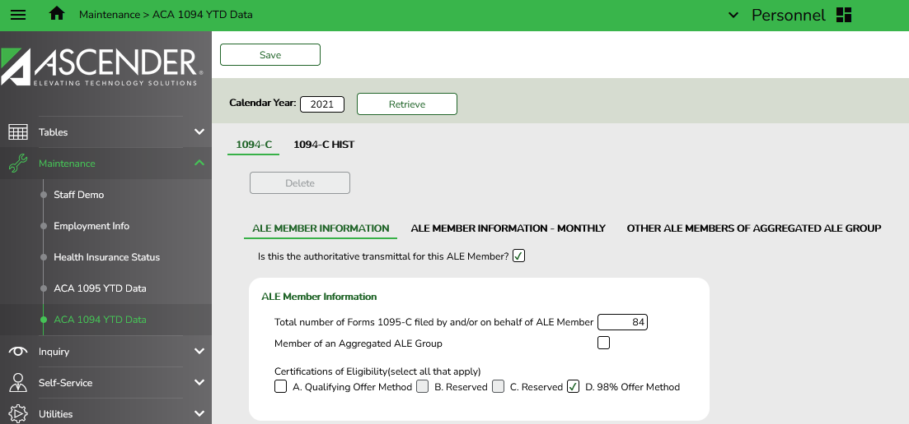

ALE Member tab:
- Select box to indicate this is the authoritative transmittal for this ALE Member.
- Note: Only one authoritative transmittal should be filed for each employer.
ALE Member Information box
In the Total number of Forms 1095-C filed by and/or on behalf of ALE Member field, type the employer's total number of filed Forms 1095-C. You can run verify the number of records by running the Reports > HR Reports > Payroll Information Reports > HRS6720 - ACA 1095 YTD Report.
Under Certifications of Eligibility, select all of the applicable codes:
- Qualifying Offer Method - Qualifying Offer applies if ALE made Minimum Value offer to at least one FT employee for all months full time, plus offered Minimum Essential Coverage to spouse and dependents costing no more than 9.5% of federal poverty level.
- 98% Offer Method – ALE offers affordable/MV coverage for all months to at least 98% of employees for whom a 1095-C is filed (enrolled FT and PT employees).

ALE Member Information – Monthly tab

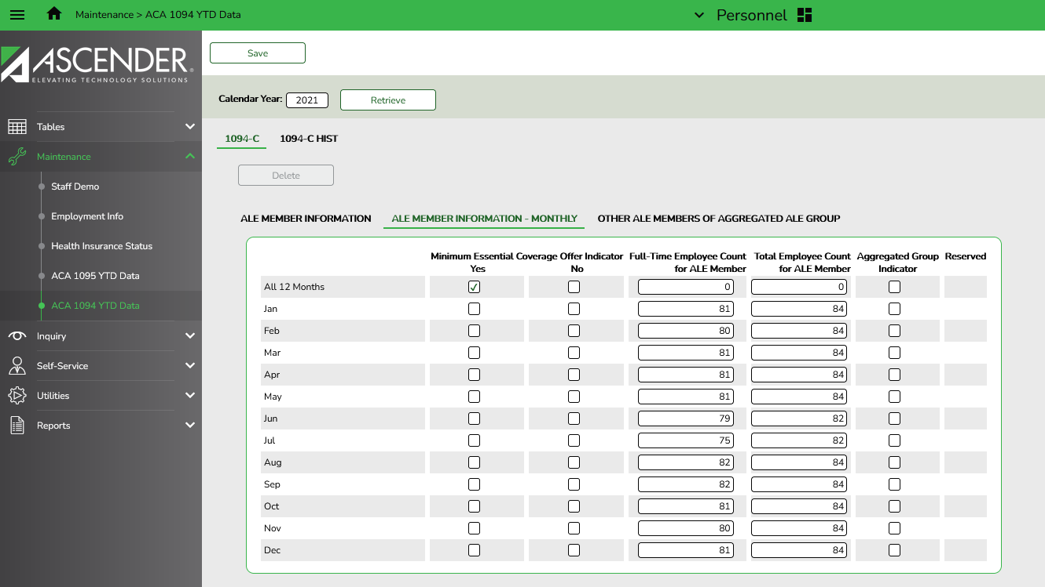

In the Minimum Essential Coverage Offer Indicator column:
- In the All 12 months field:
  - Select Yes if the employer offered the minimum essential coverage to at least 95% of its full-time employees and their dependents for the entire calendar year.
  - Select No if the employer did not offer the minimum essential coverage for all months in the calendar year.
  - If the employer offered the minimum essential coverage only in certain calendar months, select Yes or No for the applicable months.
- In the Full-Time Employee Count for ALE Member column, type the number of full-time employees for each month. If the total number of employees was the same for every month of the calendar year enter that number in the All 12 Months field.
- In the Total Employee Count for ALE member column, type the total number of employees for the ALE member either for All 12 months, or for each individual month.
- Do not check any boxes in the Aggregated Group Indicator column.

To Create AIR File to send to IRS

From Personnel > Payroll Information Reports > 1095-C Forms (HRS5255), run the report with the following parameters. You are not required to create a test file this year, though you are allowed to. We recommend you select “Y” to create the Historical Record at this time.
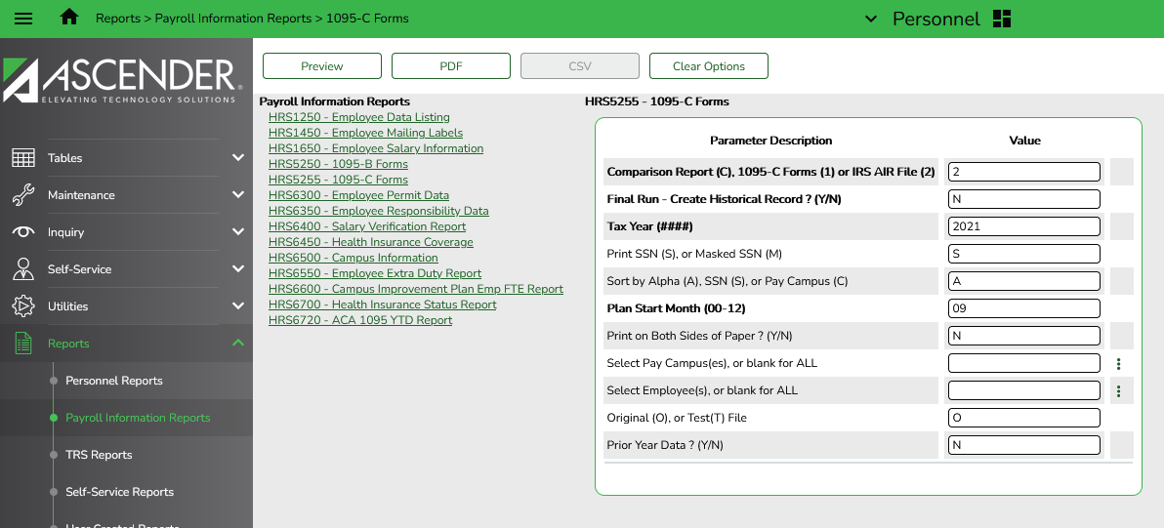

Submit file electronically using the TCC obtained earlier.

